First aid policy
Elements Diocesan Learning Trust



Approved by: | B. Newton | Date: 15.08.2025
Last reviewed on: | 13.08.2025
Next review due by: | 01.09.2026

Contents
1. Vision and Values 3
2. Aims 4
3. Legislation and guidance 5
4. Roles and responsibilities 5
5. First aid procedures 7
6. First aid equipment 8
7. Record-keeping and reporting 9
8. Training 10
9. Monitoring arrangements 11
10. Links with other policies 11
Appendix 1: First Aid Flow Chart
Appendix 2: Recording on Smartlog

This policy sets out our approach to first aid across Elements Diocesan Learning Trust.
Section 5, 6 and 7 sets out the procedures and provision for St Mary’s Primary School. First aid certificates and a list of staff who are trained will be kept in the school office,

1. Vision and Values
Together we flourish in the love of God
Elements Diocesan Learning Trust values the individual nature of each school within the Trust family. We believe that every person is a unique and precious gift, created with purpose and value. We nurture each person as a child of God and recognise their inherent potential. Through our collective efforts, we inspire hope, nurture faith, and promote the flourishing of each school.
We ensure that every person is seen, valued, and empowered to succeed, regardless of their background or circumstances. Through justice and equity, we foster an inclusive environment where diversity is celebrated, and every person’s unique gifts are honoured.
By embracing these principles, we create a culture where every person values themselves, their community, and the world around them to become compassionate, confident, and responsible individuals.
Guiding Elements

Wisdom, Knowledge and Skills

Hope and Aspiration


Dignity and Respect


Community and Living Well Together

Living out our Christian values
As a Church of England trust, we place our Christian values at the heart of all that we do.
Wisdom
The decisions we take are wise and are based on informed discussions and evidence and aimed at ensuring we achieve the best outcomes for all without forsaking our values

Hope
We have hope for a positive future and always finding positive outcomes

Honesty
We are honest with all inside and outside our organisation, whilst being sensitive to how we deliver these messages

Community and Helpfulness
We work in co-operation and partnership with all staff and wider stakeholders

Dignity and compassion
We treat all those within and outside our organisation with dignity, irrespective of the circumstances, and we show everyone compassion for the difficulties that they are experiencing

Respect
We are respectful to all, dedicated to ensuring inclusivity and diversity with those that we work with and for others that meet and our actions may affect.

Integrity
We have strong principles rooted in our Christian mission that lead our actions and decisions

Our values are founded in a Christian tradition which celebrates humanity’s unique role in the world and sets robust expectations for living life well. They set a foundation for our work, directly contributing to the aims of education, as we aim to enable everyone in our community, children and adults to ‘flourish in the love of God’ .
As Jesus commanded us to love God and one another, so we offer hospitality, compassion, and respect, accepting and celebrating the diversity of God’s creation, with everyone knowing they are valued. This is exemplified through our care and helpfulness towards others, especially those in need, knowing the worth of belonging to our immediate and wider communities. Following the profound example of Christ, the trust aims to carry out its work with wisdom, considering all appropriate factors and putting our children and young people first. God’s power enables us to work with integrity, as we carry out our Christian mission. This value highlights the duty of the trust to contribute to aspirational and hopeful futures for the children and young people we serve.

2. Aims
The aims of our first aid policy are to:
- Ensure the health and safety of all staff, pupils and visitors
- Ensure that staff and directors are aware of their responsibilities with regards to health and safety
- Provide a framework for responding to an incident and recording and reporting the outcomes

3. Legislation and guidance
This policy is based on the statutory framework for the Early Years Foundation Stage, advice from the Department for Education (DfE) on first aid in schools and health and safety in schools, guidance from the Health and Safety Executive (HSE) on incident reporting in schools, and the following legislation:
- The Health and Safety (First-Aid) Regulations 1981, which state that employers must provide adequate and appropriate equipment and facilities to enable first aid to be administered to employees, and qualified first aid personnel
- The Management of Health and Safety at Work Regulations 1992, which require employers to make an assessment of the risks to the health and safety of their employees
- The Management of Health and Safety at Work Regulations 1999, which require employers to carry out risk assessments, make arrangements to implement necessary measures, and arrange for appropriate information and training
- The Reporting of Injuries, Diseases and Dangerous Occurrences Regulations (RIDDOR) 2013, which state that some accidents must be reported to the Health and Safety Executive (HSE), and set out the timeframe for this and how long records of such accidents must be kept
- The Social Security (Claims and Payments) Regulations 1979, which set out rules on the retention of accident records
- The Education (Independent School Standards) Regulations 2014, which require that suitable space is provided to cater for the medical and therapy needs of pupils
This policy complies with our trust’s funding agreement and articles of association.

4. Roles and responsibilities
4.1 Appointed person(s) and first aiders
The appointed person(s) at each school is responsible for:
- Taking charge when someone is injured or becomes ill
- Making sure there is an adequate supply of medical materials in first aid kits, and replenishing the contents of these kits
- Making sure that an ambulance or other professional medical help is summoned when appropriate
First aiders are trained and qualified to carry out the role (see section 8) and are responsible for:
- Acting as first responders to any incidents; they will assess the situation where there is an injured or ill person, and provide immediate and appropriate treatment
- Sending pupils home to recover, where necessary
- Filling in an accident report on the same day as, or as soon as is reasonably practicable after, an incident.
- Keeping their contact details up to date
The school’s appointed person(s) and/or first aiders are listed in the school office. The school’s First Aid procedure is clearly displayed in the main office. In the EYFS, a list of all qualified First Aiders is also prominently displayed.

Appointed persons and first aiders in the central team office
For the trust’s central office, we have identified the need for an appointed person in line with HSE guidance on first aid at work.
Other than sending pupils home, the responsibilities for the central team office are the same as those listed above for school-based staff.
4.2 The board of directors
The board has ultimate responsibility for health and safety matters across the trust, but delegates operational matters and day-to-day tasks to the headteacher and staff members of each school and the appointed person at the trust’s central office.
4.3 The headteacher
The headteacher is responsible for local implementation of the policy, including:
- Making sure that an appropriate number of appointed persons and/or trained first aid personnel are present in the school at all times
- Making sure that first aiders have an appropriate qualification, keep training up to date and remain competent to perform their role
- Making sure all staff are aware of first aid procedures, including, but not limited to, the location of equipment, facilities and first aid personnel and the procedures for monitoring and reviewing the school’s first aid needs
- Making sure appropriate risk assessments are completed and appropriate measures are put in place
- Undertaking, or making sure that managers undertake, risk assessments, as appropriate, and that appropriate measures are put in place
- Making sure that adequate space is available for catering to the medical needs of pupils
- Reporting specified incidents to the HSE when necessary (see section 6)
4.4 School staff
All school staff are responsible for:
- Making sure they follow first aid procedures
- Making sure they know who the first aiders and/or appointed persons in school are
- Completing accident reports for all incidents they attend to where a first aider/appointed person is not called
- Informing the headteacher or their line manager of any specific health conditions or first aid needs

5. First aid procedures
5.1 In-school procedures
In the event of an accident resulting in injury:
- The closest member of staff present will assess the seriousness of the injury and seek the assistance of a qualified first aider, if appropriate, who will provide the required first aid treatment
- The first aider, if called, will assess the injury and decide if further assistance is needed from a colleague or the emergency services. They will remain on the scene until help arrives
- In the event of a head injury parents will always be contacted.
- If the injured person (or their parents/carers, in the case of pupils) has not provided their consent to the school to receive first aid, the first aider will act in accordance with the alternative arrangements (for example, contacting a medical professional to deliver the treatment)
- The first aider will also decide whether the injured person should be moved or placed in a recovery position
- If the first aider judges that a pupil is too unwell to remain in school, SLT will be consulted and will ask an appropriate member of staff to contact parents/carers and ask them to collect their child. Upon the parent’s/carer’s arrival, the first aider will recommend next steps to them. This incident will be recorded on Smartlog (Non-RIDDOR).
- If emergency services are called, a member of SLT will contact parents/carers immediately. The incident will be recorded on Smartlog. If the child is taken directly to hospital for treatment from the scene, a RIDDOR report will be submitted. If the child is not taken to hospital, the incident will be recorded on Smartlog as non-RIDDOR.
- The first aider will complete an accident report form on the same day or as soon as is reasonably practicable after an incident resulting in an injury
There will be at least 1 person who has a current paediatric first aid (PFA) certificate on the premises at all times.
5.2 Off-site procedures
When taking pupils off the school premises, staff will make sure that they always have the following:
- A school mobile phone
- A portable first aid kit including, at minimum:
- A leaflet giving general advice on first aid
- 6 individually wrapped sterile adhesive dressings
- 1 large sterile unmedicated dressing
- 2 triangular bandages – individually wrapped and preferably sterile
- 2 safety pins
- Individually wrapped moist cleansing wipes
- 2 pairs of disposable gloves
- Information about the specific medical needs of pupils
- Parents’/carers’ contact details
When transporting pupils using a minibus or other large vehicle, the school will make sure the vehicle is equipped with a clearly marked first aid box containing, at minimum:
- 10 antiseptic wipes, foil packed
- 1 conforming disposable bandage (not less than 7.5cm wide)
- 2 triangular bandages
- 1 packet of 24 assorted adhesive dressings
- 3 large sterile unmedicated ambulance dressings (not less than 15cm × 20 cm)
- 2 sterile eye pads, with attachments
- 12 assorted safety pins
- 1 pair of rustproof blunt-ended scissors
Risk assessments will be completed by class teachers and approved by the EVC before any educational visit that necessitates taking pupils off school premises.
The procedure in 5.1 will be followed as closely as possible for any off-site accidents (though whether the parents/carers can collect their child will depend on the location and duration of the trip).
There will always be at least 1 first aider with a current paediatric first aid certificate on school trips and visits, as required by the statutory framework for the Early Years Foundation Stage.
There will always be at least 1 first aider on school trips and visits.
5.3 Central office procedures
The closest member of staff present will assess the seriousness of the injury and decide if the emergency services or a non-emergency medical professional needs to be contacted. They will remain on the scene until help arrives, and complete an accident report form.

6. First aid equipment
A typical first aid kit in our schools will include the following:
- A leaflet giving general advice on first aid
- 20 individually wrapped sterile adhesive dressings (assorted sizes)
- 2 sterile eye pads
- 2 individually wrapped triangular bandages (preferably sterile)
- 6 safety pins
- 6 medium-sized individually wrapped sterile unmedicated wound dressings
- 2 large sterile individually wrapped unmedicated wound dressings
- 3 pairs of disposable gloves
No medication is kept in first aid kits.
First aid kits are stored in:
- Reception (at the desk)
- The school hall
- All Classrooms
- The school kitchen
- Staff room
See section 5.2 for first aid equipment off the school site.

7. Record-keeping and reporting
7.1 First aid and accident record book
- An accident form will be completed by the first aider on the same day or as soon as possible after an incident resulting in an injury
- As much detail as possible will be supplied when reporting an accident.
- For accidents involving pupils, a copy of the accident report form will also be added to the pupil’s educational record on CPOMs by a teacher or member of SLT.
- Records held in the first aid and accident book will be retained by the school for a minimum of 3 years, in accordance with regulation 25 of the Social Security (Claims and Payments) Regulations 1979, and then securely disposed of.
7.2 Reporting to the HSE
The headteacher will keep a record of any accident which results in a reportable injury, disease, or dangerous occurrence as defined in the RIDDOR 2013 legislation (regulations 4, 5, 6 and 7).
The headteacher will report these to the HSE as soon as is reasonably practicable and in any event within 10 days of the incident – except where indicated below. Fatal and major injuries and dangerous occurrences will be reported without delay (i.e. by telephone) and followed up in writing within 10 days.
School staff: reportable injuries, diseases or dangerous occurrences
These include:
- Death
- Specified injuries, which are:
- Fractures, other than to fingers, thumbs and toes
- Amputations
- Any injury likely to lead to permanent loss of sight or reduction in sight
- Any crush injury to the head or torso causing damage to the brain or internal organs
- Serious burns (including scalding) which:
  - Covers more than 10% of the whole body’s total surface area; or
  - Causes significant damage to the eyes, respiratory system or other vital organs
- Any scalping requiring hospital treatment
- Any loss of consciousness caused by head injury or asphyxia
- Any other injury arising from working in an enclosed space which leads to hypothermia or heat-induced illness, or requires resuscitation or admittance to hospital for more than 24 hours
- Work-related injuries that lead to an employee being away from work or unable to perform their normal work duties for more than 7 consecutive days (not including the day of the incident). In this case, the headteacher will report these to the HSE as soon as reasonably practicable and in any event within 15 days of the accident
- Occupational diseases where a doctor has made a written diagnosis that the disease is linked to occupational exposure. These include:
  - Carpal tunnel syndrome
  - Severe cramp of the hand or forearm
  - Occupational dermatitis, e.g. from exposure to strong acids or alkalis, including domestic bleach
  - Hand-arm vibration syndrome
  - Occupational asthma, e.g. from wood dust
  - Tendonitis or tenosynovitis of the hand or forearm
  - Any occupational cancer
  - Any disease attributed to an occupational exposure to a biological agent
- Near-miss events that do not result in an injury, but could have done. Examples of near-miss events relevant to schools include, but are not limited to:
  - The collapse or failure of load-bearing parts of lifts and lifting equipment
  - The accidental release of a biological agent likely to cause severe human illness
  - The accidental release or escape of any substance that may cause a serious injury or damage to health
  - An electrical short circuit or overload causing a fire or explosion
Pupils and other people who are not at work (e.g. visitors): reportable injuries, diseases or dangerous occurrences
These include:
- Death of a person that arose from, or was in connection with, a work activity*
- An injury that arose from, or was in connection with, a work activity* and where the person is taken directly from the scene of the accident to hospital for treatment
*An accident “arises out of” or is “connected with a work activity” if it was caused by:
- A failure in the way a work activity was organised (e.g. inadequate supervision of a field trip)
- The way equipment or substances were used (e.g. lifts, machinery, experiments etc); and/or
- The condition of the premises (e.g. poorly maintained or slippery floors)
Information on how to make a RIDDOR report is available here:
How to make a RIDDOR report, HSE
http://www.hse.gov.uk/riddor/report.htm
7.3 Notifying parents/carers (early years only)
An appropriate adult will inform parents/carers of any accident or injury sustained by a pupil, and any first aid treatment given, on the same day, or as soon as reasonably practicable. Parents/carers will also be informed if emergency services are called.
In accordance with statutory requirements, Ofsted will be notified within 14 days of any serious accident, injury, or illness involving a child in EYFS care. This includes incidents requiring hospital admission, resuscitation, or emergency medical intervention. Further information can be found here:
Childcare: reporting children’s accidents and injuries - GOV.UK

8. Training
All staff are able to undertake first aid training if they would like to.
All first aiders must have completed a training course and must hold a valid certificate of competence to show this. The school will keep a register of all trained first aiders, what training they have received and when this is valid until.
The school will arrange for first aiders to retrain before their first aid certificates expire. In cases where a certificate expires, the school will arrange for staff to retake the full first aid course before being reinstated as a first aider.
At all times, at least 1 staff member will have a current paediatric first aid (PFA) certificate that meets the requirements set out in the EYFS statutory framework. The PFA certificate will be renewed every 3 years.

9. Monitoring arrangements
This policy will be monitored by the CEO and reviewed annually.
At every review, the policy will be approved by the board of directors
The first aid provision will be reviewed by the headteacher and first aiders at least annually.

10. Links with other policies
This first aid policy is linked to the:
- Health and safety policy
- Risk assessment policy
- Policy on supporting pupils with medical conditions

Appendix 1: First Aid Record - Decision Flow Chart
The Headteacher holds overall responsibility for ensuring that all first aid incidents are appropriately recorded. They have access to Smartlog and must ensure that any incidents meeting RIDDOR criteria are reported promptly and accurately. While the task of logging first aid incidents may be delegated to a designated staff member, this delegation must be clearly defined and regularly monitored to ensure compliance and consistency.

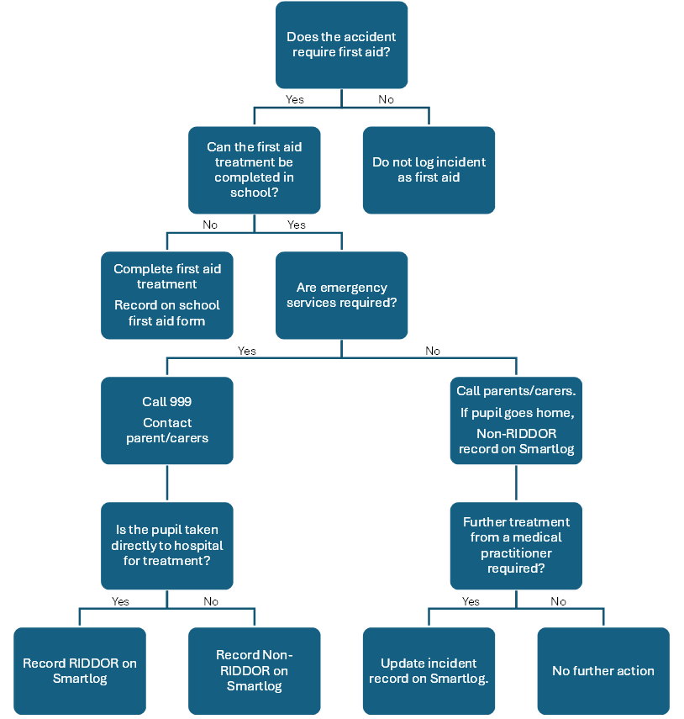

Appendix 2: Accident Reporting on Smartlog
Submitting a report
Select Accident reporting then Report Accident/incident.
A blank form can be downloaded on the page which opens if needed to support information collection.
Complete all sections of the online form with as much detail as possible.
Submit the completed form.

Completing a report
Once further information is known and investigation into the circumstances of the incident has been done, the submitted form must be followed up.
Select Submitted Accident Reports.
Select the submitted report from the list shown.
Check the information in the submitted report is accurate and add any further information known.
Scroll down to Section 4 to 7 and complete these parts.
Do not select checks from Section 4 if they are not applicable. Add notes in Section 6: ‘Follow up notes and tasks’ to detail your findings.

This form can be saved if actions from the First Aid flowchart have not yet been completed.
If the accident needs to be reported as RIDDOR, the link for the online forms can be accessed from Smartlog. The RIDDOR report should be saved and uploaded to Smartlog and the reference added to the form.
Once all actions are done select Complete to finish the report.


