First Day Contact Procedure
St. Mary’s CE Primary School



Approved by: | Elizabeth Green | Date: 6th September 2024
Last reviewed on: | September 2024
Next review due by: | September 2025


Aims:

St Mary’s CE Primary School is committed to safeguarding and promoting the welfare of all children and young people both within the school environment and outside. We constantly review and update procedures in school to ensure we keep up to date with advice available from other agencies including the outcomes of Serious Case reviews.

Information on what Serious Case reviews are, is available on the NSPCC website and reproduced below:
A serious case review (SCR) takes place after a child dies or is seriously injured and abuse or neglect is thought to be involved. It looks at lessons that can help prevent similar incidents from happening in the future.
Other parts of the UK have their own systems in place to learn from cases. In Wales they are called child practice reviews; in Northern Ireland, case management reviews and in Scotland, significant case reviews.
A SCR should take place if abuse or neglect is known, or suspected, to have been involved and
- a child has died
- or a child has been seriously harmed and there is cause for concern about how organisations or professionals worked together to safeguard the child
Or
- the child dies in custody
- or a child died by suspected suicide.
https://www.nspcc.org.uk/preventing-abuse/child-protection-system/england/serious-case-reviews/

Context:

A number of recent Serious Case reviews have highlighted times where a robust intervention by a school, checking the whereabouts and safety of absent children could have decreased the harm to those children. A number of recent incidents were:

A mum died from an epileptic fit while bathing her children age 3 and 4. The next morning the school phoned home immediately after checking registers. There was no answer so school continued ringing through the Emergency contact list until they had an answer. A family member went straight to the house and found mum had died, but the children were safe.
- A father died from natural causes. Mum was working away from home and Dad was caring for the children aged 2 and 4. In the morning Mum rang dad but received no answer. She assumed he was taking the children to school and continued with her working day. The school noted the absence of the 4-year-old. They started calling 2 hours after registration and rang Dad only, leaving a message. They did not ring anyone else on the contact list. They repeated the call to Dad at 3.40. Mum rang home at the end of her working day and now worried rang another school mum. Grandmother went to the home but could not gain access
due to a key in the lock inside. The police gained entry at 8pm but by that time the children had been alone with their deceased father all day.
- A mum died. School made a call to her when her child was not at school but the contact list was not used so no further calls were made. A letter was sent to the parent 3 days later. Eventually the house was entered 5 days later. The child, age 6 or 7 had also died. The child was non-verbal so would not have been able to call for help.
Whilst these examples seem extreme, they are still continuing. Following a robust First Day Contact Procedure should minimise the risk of harm to children.
Procedure:
It is important that we have the following information from parents:
- Complete and up to date contact information for a number of trusted adults that would have access to the home if required
- Contact made before 9:30am on the first day of a child’s absence.
The following page has a flow chart to show the procedure followed by school.

First Day Contact Flow Chart Administration Staff
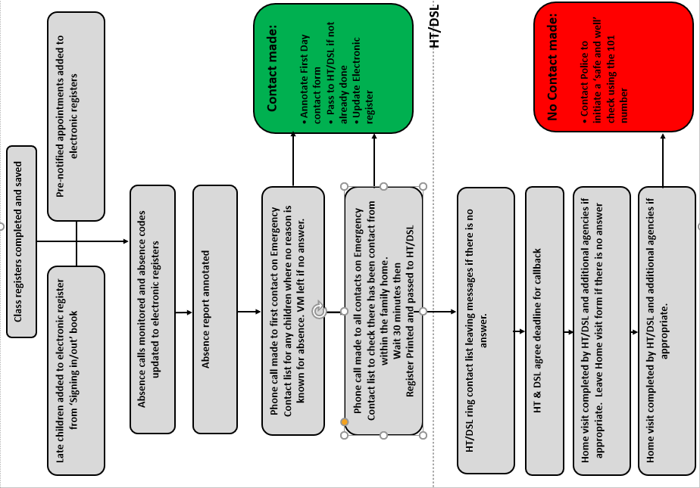

Date _____________________________ Time______________________________________

Child’s name ___________________________________________________________________

Dear Parent,

As part of our First Day Procedures, we have visited your house to check the welfare of your child and you.

Please contact St. Mary’s CE Primary school by telephone as a matter of urgency on 01384 818295.
The next step in our procedure is to ask the Police to initiate a ‘Safe and Well’ check. I will be making this call on my return to school.

Yours Sincerely,

Mrs A Wainwright

